**Some MUST READ tips before you do the firmware & software upgrade**

**Please check your GD-77 firmware version before upgrade:**

Turn on the radio---Open the menu---Set---Radio info---Dev. info---below Soft Version: VX.X.X.

* V2.6.6, V2.6.8, V3.0.6----upgrade directly to V3.1.1 or higher versions
* V2.6.2, V2.4.2 or others lower than V2.6.6----upgrade firstly to V2.6.6 or V2.6.8 or V3.0.6 then to V3.1.1 or higher versions

**Otherwise it might cause Abnormal power after reset on the GD-77.**

**Before updating the firmware, please note:**

* Firmware V2.6.6 and before V2.6.6 are compatible with software V1.1.8
* Firmware V3.0.6 is compatible with software V2.0.5
* Firmware V3.1.1 and after V3.1.1 are compatible with software V3.1.1

**If the old version of your radio firmware is not compatible with the new software, the upgrade operation will overwrite your old data. Please save the codeplug in advance and use the new CPS to export/import a new template to copy the bulk data into a new codeplug after upgrade.**

**Firmware upgrade operation**

1. Turn off the radio and then plug in the programming cable.
2. Hard press the side key 1 and the side key 2 for one second and then turn on the radio (still pressing the keys). The radio will be in upgrade mode when the indicator light is on and the screen is black.

<https://drive.google.com/file/d/1jjEWB_aGvYdjyrSPhSmyw70GeGV0MlQW/view?usp=sharing>

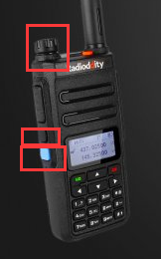

3. Open the upgrade software "Update.exe"

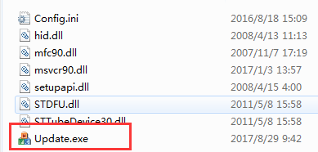

P.S. If you fail to open this application, please run the ‘’**vcredist_x86_2008**’’ database first and then restart your computer and try the upgrade again.

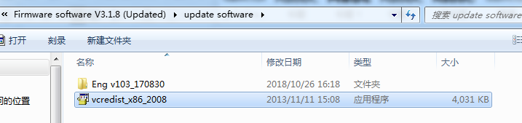

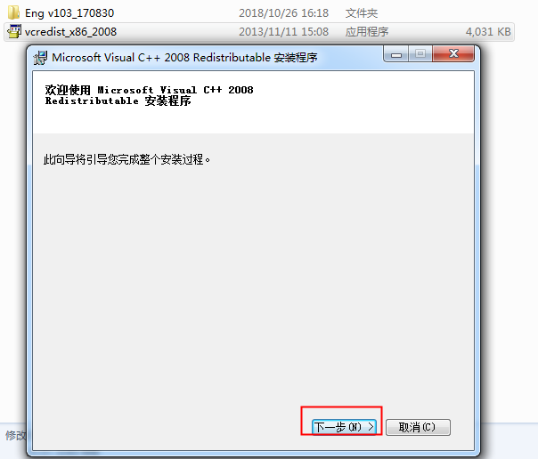

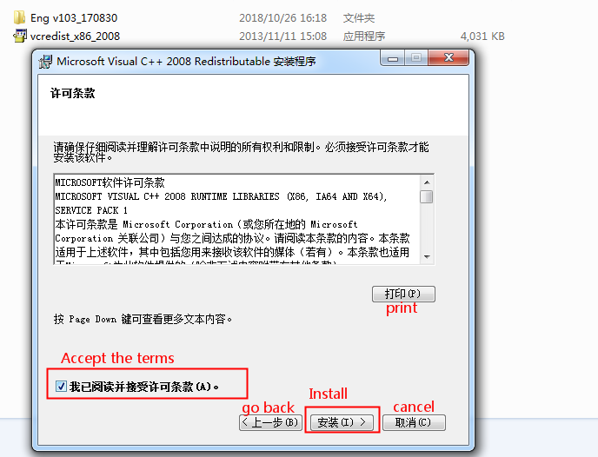

4. Click "Browse" to select the file to be upgraded, for example: GD-77_V3.1.8.sgl,

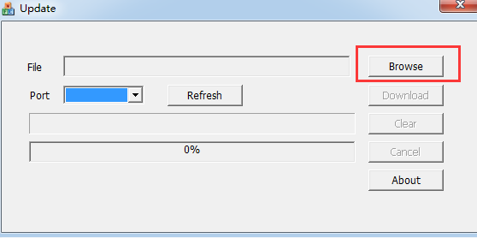

5. Click "Download" to complete the upgrade.

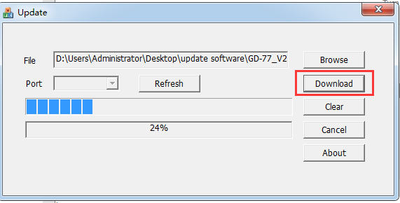

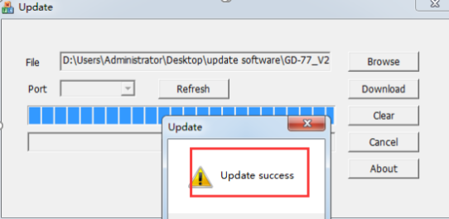

6. Unplug programming cable, turn off the radio for at least 2 seconds and then turn the radio back on to perform reboot GD-77.

**If your radio is upgraded from V2.6.6 to V3.1.1 or higher, please follow these steps after updated:**

a. Download and open the new software V3.1.1

b. Connect the radio to computer

c. Write the default data from the new software to the radio directly (Please DO NOT "read", or it will lead to unknown error. Reason: Some parts of the data storage location has changed.)

d. Turn off the radio for at least 2 seconds and then turn the radio back on to perform reboot the GD-77. Then you can start to program the radio with the new programming software.

e. Please use the new software template for batch import.

**Note: Do NOT import the old codeplugs and templates from the old programming software to the new programming software or to your upgraded radio.**

**The upgrade operation will overwrite your old data, please save the codeplug and export the contacts and channels as CSV files in advance.**

**What’s NEW with this software V3.1.1 & firmware**

**1. ADD VFO**

How to enter VFO mode: short press the right arrow key on the keypad → to switch the VFO and MR; short press the left arrow key ← to switch the frequency bands.

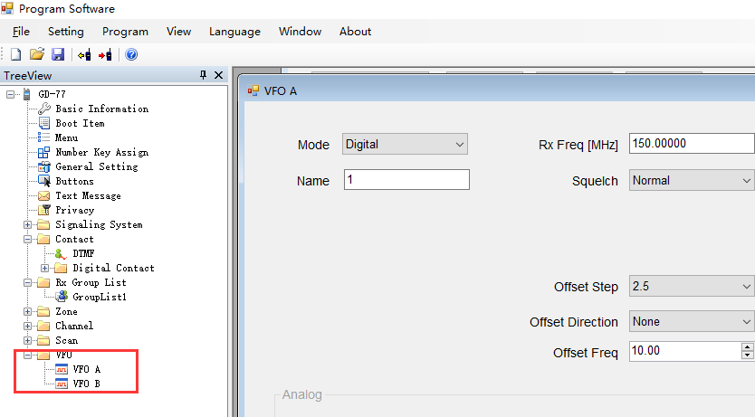

**2. Contact ID**

The number of digital contact IDs has been expanded from 256 to 1000.

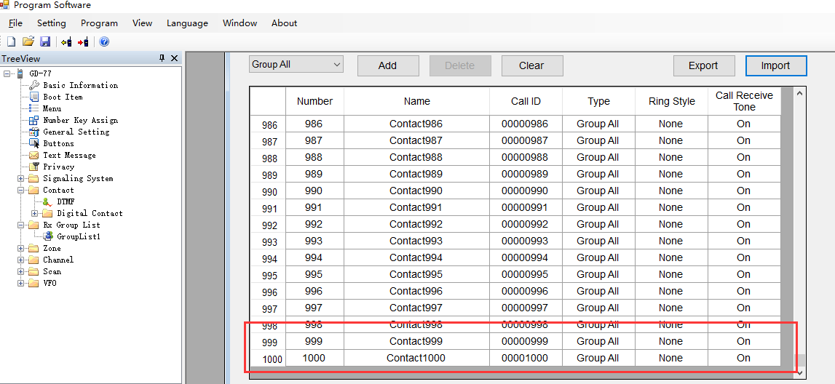

**3. Scan list & Channel list**

The number of scan list is expanded from 16 to 64, and the number of channel list is expanded from 16 to 31.

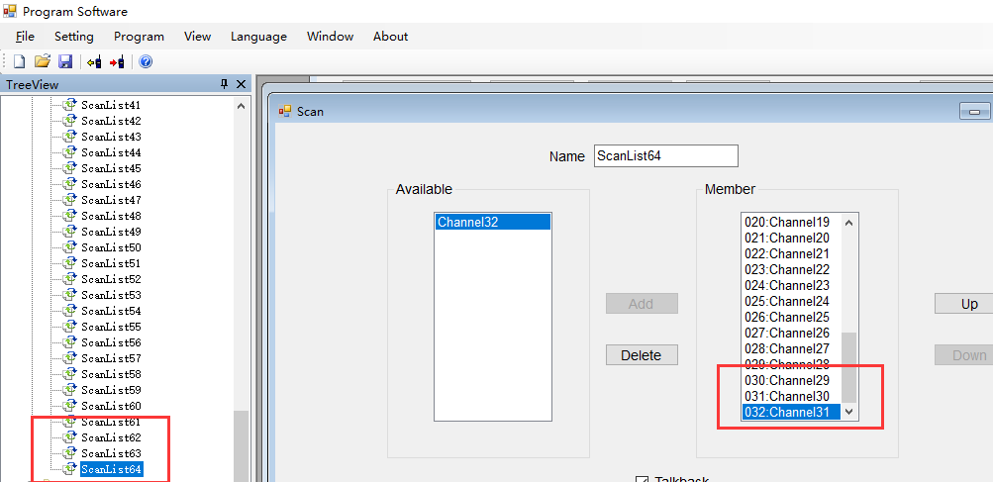

**4. DMR ID Database**

We provide a total of 49607 people with DMR IDs registered globally, under the file name “datadump”. As GD-77 can only support saving the top 10000 from the list as default, please select the IDs you want to add.

For more details of the import operation, see: DMR ID operation.

Note:

1：Read and write DMR ID data: Press **SK2**+**Menu**+**# key** at the same time to turn on radio

2：Please DO NOT delete or modify the first row

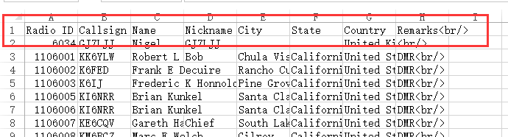

5. Fix the bug of zones lost

6. Fix the bug of distorted audio